L1F23BSSE0372
Muhammad Arham

Task1:
Output:
import javax.swing.*;
import javax.swing.border.*;
import java.awt.*;
import java.awt.geom.*;
/**
* Q1: Login Panel GUI - Design Only (No Event Handling)
* Frame Title: "JPanel Demo Program"
* Features stunning gradient background, glass-morphism style login panel
*/
public class Q1_LoginPanel extends JFrame {
// ─── Custom Colors ───────────────────────────────────────────────
private static final Color BG_TOP = new Color(15, 32, 65); // deep navy
private static final Color BG_BOTTOM = new Color(30, 80, 140); // ocean blue
private static final Color PANEL_BG = new Color(255, 255, 255, 30); // translucent white
private static final Color ACCENT = new Color(99, 179, 237); // sky blue
private static final Color BTN_COLOR = new Color(56, 161, 105); // green
private static final Color WHITE = Color.WHITE;
public Q1_LoginPanel() {
setTitle("JPanel Demo Program");
setSize(480, 560);
setDefaultCloseOperation(EXIT_ON_CLOSE);
setLocationRelativeTo(null);
setResizable(false);
// Gradient background panel as the content pane
JPanel background = new GradientPanel(BG_TOP, BG_BOTTOM);
background.setLayout(new GridBagLayout());
setContentPane(background);
// ─── Login Panel (inner card) ──────────────────────────────
JPanel loginPanel = new RoundedPanel(30, new Color(255, 255, 255, 25));
loginPanel.setLayout(new GridBagLayout());
loginPanel.setPreferredSize(new Dimension(360, 400));
loginPanel.setBorder(BorderFactory.createEmptyBorder(30, 35, 30, 35));
GridBagConstraints gbc = new GridBagConstraints();
gbc.insets = new Insets(10, 0, 10, 0);
gbc.fill = GridBagConstraints.HORIZONTAL;
gbc.gridwidth = GridBagConstraints.REMAINDER;
// ── Panel title ──
JLabel titleLabel = new JLabel("🔐 Login Panel", SwingConstants.CENTER);
titleLabel.setFont(new Font("Segoe UI", Font.BOLD, 22));
titleLabel.setForeground(WHITE);
gbc.insets = new Insets(0, 0, 25, 0);
loginPanel.add(titleLabel, gbc);
// ── Subtitle ──
JLabel subtitle = new JLabel("Welcome back! Please sign in.", SwingConstants.CENTER);
subtitle.setFont(new Font("Segoe UI", Font.PLAIN, 13));
subtitle.setForeground(new Color(180, 210, 255));
gbc.insets = new Insets(0, 0, 20, 0);
loginPanel.add(subtitle, gbc);
// ── Separator line ──
JSeparator sep = new JSeparator();
sep.setForeground(new Color(99, 179, 237, 80));
gbc.insets = new Insets(0, 0, 20, 0);
loginPanel.add(sep, gbc);
// ── Username Label ──
JLabel userLabel = new JLabel(" Username");
userLabel.setFont(new Font("Segoe UI", Font.BOLD, 13));
userLabel.setForeground(ACCENT);
gbc.insets = new Insets(5, 0, 3, 0);
loginPanel.add(userLabel, gbc);
// ── Username Field ──
JTextField userField = new StyledTextField("Enter your username");
gbc.insets = new Insets(0, 0, 12, 0);
loginPanel.add(userField, gbc);
// ── Password Label ──
JLabel passLabel = new JLabel(" Password");
passLabel.setFont(new Font("Segoe UI", Font.BOLD, 13));
passLabel.setForeground(ACCENT);
gbc.insets = new Insets(5, 0, 3, 0);
loginPanel.add(passLabel, gbc);
// ── Password Field ──
JPasswordField passField = new JPasswordField();
stylePasswordField(passField);
gbc.insets = new Insets(0, 0, 25, 0);
loginPanel.add(passField, gbc);
// ── Login Button ──
JButton loginBtn = new RoundedButton(" LOGIN", BTN_COLOR);
loginBtn.setPreferredSize(new Dimension(290, 45));
gbc.insets = new Insets(10, 0, 5, 0);
loginPanel.add(loginBtn, gbc);
// ── Bottom note ──
JLabel note = new JLabel("Forgot password? Reset here", SwingConstants.CENTER);
note.setFont(new Font("Segoe UI", Font.PLAIN, 12));
note.setForeground(new Color(150, 190, 255));
gbc.insets = new Insets(10, 0, 0, 0);
loginPanel.add(note, gbc);
// Add login panel to background
background.add(loginPanel);
setVisible(true);
}
// ── Utility: style the password field ──
private void stylePasswordField(JPasswordField f) {
f.setPreferredSize(new Dimension(290, 42));
f.setFont(new Font("Segoe UI", Font.PLAIN, 14));
f.setForeground(WHITE);
f.setBackground(new Color(255, 255, 255, 20));
f.setCaretColor(WHITE);
f.setBorder(BorderFactory.createCompoundBorder(
new RoundedBorder(10, ACCENT),
BorderFactory.createEmptyBorder(5, 12, 5, 12)
));
f.setOpaque(false);
}
// ════════════════════════════════════════════════════════════════
// Inner Classes – Custom UI Components
// ════════════════════════════════════════════════════════════════
/** Panel that paints a top-to-bottom gradient */
static class GradientPanel extends JPanel {
private final Color top, bottom;
GradientPanel(Color top, Color bottom) {
this.top = top; this.bottom = bottom;
setOpaque(true);
}
@Override protected void paintComponent(Graphics g) {
Graphics2D g2 = (Graphics2D) g;
g2.setRenderingHint(RenderingHints.KEY_RENDERING, RenderingHints.VALUE_RENDER_QUALITY);
GradientPaint gp = new GradientPaint(0, 0, top, 0, getHeight(), bottom);
g2.setPaint(gp);
g2.fillRect(0, 0, getWidth(), getHeight());
}
}
/** Panel with rounded corners and translucent fill */
static class RoundedPanel extends JPanel {
private final int arc;
private final Color fill;
RoundedPanel(int arc, Color fill) {
this.arc = arc; this.fill = fill;
setOpaque(false);
}
@Override protected void paintComponent(Graphics g) {
Graphics2D g2 = (Graphics2D) g.create();
g2.setRenderingHint(RenderingHints.KEY_ANTIALIASING, RenderingHints.VALUE_ANTIALIAS_ON);
g2.setColor(fill);
g2.fillRoundRect(0, 0, getWidth(), getHeight(), arc, arc);
// subtle border
g2.setColor(new Color(255, 255, 255, 60));
g2.setStroke(new BasicStroke(1.5f));
g2.drawRoundRect(1, 1, getWidth()-2, getHeight()-2, arc, arc);
g2.dispose();
super.paintComponent(g);
}
}
/** Stylish text field with rounded border */
static class StyledTextField extends JTextField {
StyledTextField(String placeholder) {
setText(placeholder);
setPreferredSize(new Dimension(290, 42));
setFont(new Font("Segoe UI", Font.PLAIN, 14));
setForeground(new Color(180, 200, 255));
setBackground(new Color(255, 255, 255, 20));
setCaretColor(Color.WHITE);
setOpaque(false);
setBorder(BorderFactory.createCompoundBorder(
new RoundedBorder(10, new Color(99, 179, 237)),
BorderFactory.createEmptyBorder(5, 12, 5, 12)
));
}
}
/** Rounded border with custom color */
static class RoundedBorder extends AbstractBorder {
private final int radius;
private final Color color;
RoundedBorder(int radius, Color color) { this.radius = radius; this.color = color; }
@Override public void paintBorder(Component c, Graphics g, int x, int y, int w, int h) {
Graphics2D g2 = (Graphics2D) g.create();
g2.setRenderingHint(RenderingHints.KEY_ANTIALIASING, RenderingHints.VALUE_ANTIALIAS_ON);
g2.setColor(color);
g2.setStroke(new BasicStroke(1.5f));
g2.drawRoundRect(x, y, w-1, h-1, radius, radius);
g2.dispose();
}
}
/** Pill-shaped button with hover effect (design only) */
static class RoundedButton extends JButton {
private final Color base;
RoundedButton(String text, Color base) {
super(text);
this.base = base;
setFont(new Font("Segoe UI", Font.BOLD, 14));
setForeground(Color.WHITE);
setFocusPainted(false);
setBorderPainted(false);
setContentAreaFilled(false);
setCursor(Cursor.getPredefinedCursor(Cursor.HAND_CURSOR));
}
@Override protected void paintComponent(Graphics g) {
Graphics2D g2 = (Graphics2D) g.create();
g2.setRenderingHint(RenderingHints.KEY_ANTIALIASING, RenderingHints.VALUE_ANTIALIAS_ON);
GradientPaint gp = new GradientPaint(0, 0, base.brighter(), 0, getHeight(), base.darker());
g2.setPaint(gp);
g2.fillRoundRect(0, 0, getWidth(), getHeight(), 25, 25);
g2.dispose();
super.paintComponent(g);
}
}
public static void main(String[] args) {
// Use system look and feel as base, then override with our custom painting
try { UIManager.setLookAndFeel(UIManager.getCrossPlatformLookAndFeelClassName()); }
catch (Exception ignored) {}
SwingUtilities.invokeLater(Q1_LoginPanel::new);
}
}
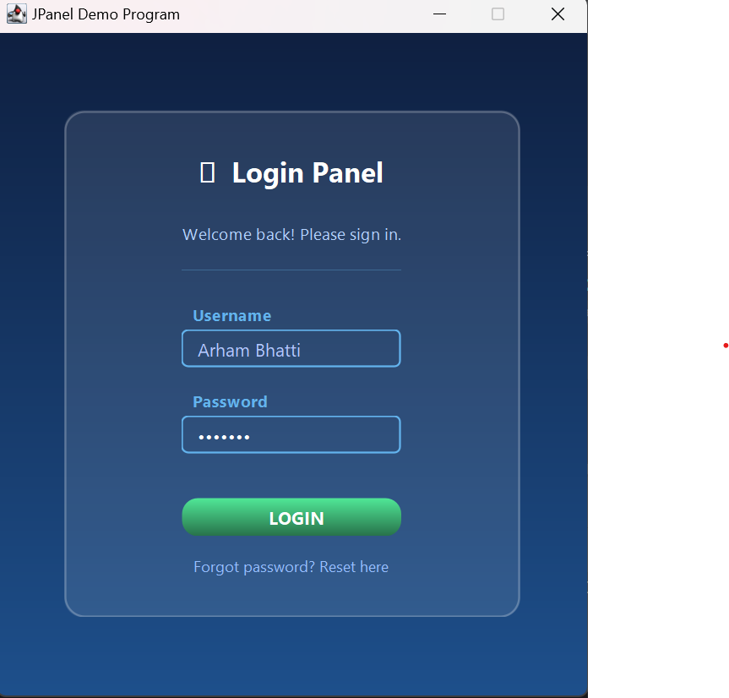
Task 2:
import javax.swing.*;
import javax.swing.border.*;
import java.awt.*;
import java.awt.geom.*;
/**
* Q2: TV Remote Controller - Design Only (No Event Handling)
* Beautiful modern remote with gradient body, glowing buttons,
* Power, Channel, Volume, and Media source controls.
*/
public class Q2_TVRemote extends JFrame {
// ─── Palette ─────────────────────────────────────────────────────
private static final Color BODY_TOP = new Color(28, 28, 40);
private static final Color BODY_BOTTOM = new Color(18, 18, 28);
private static final Color RED_BTN = new Color(220, 53, 69);
private static final Color GREEN_BTN = new Color(40, 167, 69);
private static final Color BLUE_BTN = new Color(0, 123, 255);
private static final Color YELLOW_BTN = new Color(255, 193, 7);
private static final Color NAV_BTN = new Color(55, 65, 90);
private static final Color NAV_HOVER = new Color(70, 85, 115);
private static final Color TEXT_DIM = new Color(160, 170, 200);
private static final Color DISPLAY_BG = new Color(10, 20, 45);
private static final Color DISPLAY_FG = new Color(0, 255, 160); // matrix green
private static final Color GLOW_CYAN = new Color(0, 210, 255);
public Q2_TVRemote() {
setTitle("TV Remote Controller");
setSize(340, 760);
setDefaultCloseOperation(EXIT_ON_CLOSE);
setLocationRelativeTo(null);
setResizable(false);
// Dark gradient background
JPanel bg = new GradientBg(new Color(10, 10, 20), new Color(25, 30, 55));
bg.setLayout(new GridBagLayout());
setContentPane(bg);
// ── Remote body ──────────────────────────────────────────────
JPanel remote = new RemoteBody();
remote.setLayout(new BoxLayout(remote, BoxLayout.Y_AXIS));
remote.setPreferredSize(new Dimension(270, 700));
remote.setBorder(BorderFactory.createEmptyBorder(20, 22, 20, 22));
// ── Brand bar at top ──
remote.add(makeBrandBar());
remote.add(Box.createVerticalStrut(12));
// ── Mini LCD display ──
remote.add(makeLCDDisplay());
remote.add(Box.createVerticalStrut(14));
// ── Power button (big, centred, red) ──
remote.add(makeCenteredRow(makePowerButton()));
remote.add(Box.createVerticalStrut(14));
// ── Divider ──
remote.add(makeDivider());
remote.add(Box.createVerticalStrut(10));
// ── Section label: CHANNEL ──
remote.add(sectionLabel("CHANNEL"));
remote.add(Box.createVerticalStrut(6));
// ── Channel Up / Down ──
remote.add(makeRow(
makeNavButton("CH ▲", "Channel Up", BLUE_BTN),
makeNavButton("CH ▼", "Channel Down", NAV_BTN)
));
remote.add(Box.createVerticalStrut(12));
// ── Section label: VOLUME ──
remote.add(sectionLabel("VOLUME"));
remote.add(Box.createVerticalStrut(6));
// ── Volume Up / Down ──
remote.add(makeRow(
makeNavButton("VOL +", "Volume Up", GREEN_BTN),
makeNavButton("VOL −", "Volume Down", NAV_BTN)
));
remote.add(Box.createVerticalStrut(14));
// ── Divider ──
remote.add(makeDivider());
remote.add(Box.createVerticalStrut(10));
// ── Section label: INPUT SOURCE ──
remote.add(sectionLabel("INPUT SOURCE"));
remote.add(Box.createVerticalStrut(8));
// ── Media source buttons ──
remote.add(makeMediaRow());
remote.add(Box.createVerticalStrut(14));
// ── Number pad (decorative) ──
remote.add(sectionLabel("KEYPAD"));
remote.add(Box.createVerticalStrut(6));
remote.add(makeNumpad());
remote.add(Box.createVerticalStrut(10));
bg.add(remote);
setVisible(true);
}
// ════════════════════════════════════════════════════════════════
// Component Builders
// ════════════════════════════════════════════════════════════════
private JPanel makeBrandBar() {
JPanel p = transparent();
p.setLayout(new BorderLayout());
JLabel brand = new JLabel("VIZIO 🖥", SwingConstants.CENTER);
brand.setFont(new Font("Segoe UI", Font.BOLD, 18));
brand.setForeground(GLOW_CYAN);
brand.setAlignmentX(CENTER_ALIGNMENT);
JLabel subtitle = new JLabel("Smart Remote • v3.0", SwingConstants.CENTER);
subtitle.setFont(new Font("Segoe UI", Font.PLAIN, 10));
subtitle.setForeground(TEXT_DIM);
JPanel inner = new JPanel();
inner.setOpaque(false);
inner.setLayout(new BoxLayout(inner, BoxLayout.Y_AXIS));
brand.setAlignmentX(CENTER_ALIGNMENT);
subtitle.setAlignmentX(CENTER_ALIGNMENT);
inner.add(brand); inner.add(Box.createVerticalStrut(2)); inner.add(subtitle);
p.add(inner, BorderLayout.CENTER);
return p;
}
private JPanel makeLCDDisplay() {
JPanel display = new RoundedSolid(12, DISPLAY_BG);
display.setPreferredSize(new Dimension(226, 52));
display.setMaximumSize(new Dimension(Integer.MAX_VALUE, 52));
display.setBorder(BorderFactory.createEmptyBorder(8, 14, 8, 14));
display.setLayout(new BorderLayout());
JLabel ch = new JLabel("CH 07", SwingConstants.LEFT);
ch.setFont(new Font("Courier New", Font.BOLD, 16));
ch.setForeground(DISPLAY_FG);
JLabel vol = new JLabel("VOL 32", SwingConstants.RIGHT);
vol.setFont(new Font("Courier New", Font.BOLD, 16));
vol.setForeground(DISPLAY_FG);
display.add(ch, BorderLayout.WEST);
display.add(vol, BorderLayout.EAST);
return display;
}
/** Big glowing power button */
private JButton makePowerButton() {
JButton btn = new GlowButton("⏻ POWER", RED_BTN, 38, 26);
btn.setPreferredSize(new Dimension(160, 46));
btn.setMaximumSize(new Dimension(160, 46));
return btn;
}
/** Channel / Volume nav buttons in a side-by-side row */
private JPanel makeRow(JButton left, JButton right) {
JPanel row = transparent();
row.setLayout(new GridLayout(1, 2, 10, 0));
row.setMaximumSize(new Dimension(Integer.MAX_VALUE, 46));
row.add(left); row.add(right);
return row;
}
private JButton makeNavButton(String label, String tooltip, Color c) {
JButton btn = new GlowButton(label, c, 14, 20);
btn.setToolTipText(tooltip);
btn.setPreferredSize(new Dimension(108, 44));
return btn;
}
/** TV / USB / HDMI row */
private JPanel makeMediaRow() {
JPanel row = transparent();
row.setLayout(new GridLayout(1, 3, 8, 0));
row.setMaximumSize(new Dimension(Integer.MAX_VALUE, 44));
String[] labels = { "📺 TV", "🔌 USB", "🖥 HDMI" };
Color[] colors = { BLUE_BTN, YELLOW_BTN, GREEN_BTN };
for (int i = 0; i < 3; i++) {
JButton b = new GlowButton(labels[i], colors[i], 12, 18);
b.setPreferredSize(new Dimension(72, 40));
row.add(b);
}
return row;
}
/** 3 × 3 digit pad (1–9) + back + 0 + ok */
private JPanel makeNumpad() {
String[] keys = {"1","2","3","4","5","6","7","8","9","⬅","0","OK"};
Color[] cols = {
NAV_BTN, NAV_BTN, NAV_BTN,
NAV_BTN, NAV_BTN, NAV_BTN,
NAV_BTN, NAV_BTN, NAV_BTN,
new Color(100,60,60), NAV_BTN, new Color(40,100,60)
};
JPanel pad = transparent();
pad.setLayout(new GridLayout(4, 3, 7, 7));
pad.setMaximumSize(new Dimension(Integer.MAX_VALUE, 170));
for (int i = 0; i < keys.length; i++) {
JButton b = new GlowButton(keys[i], cols[i], 13, 18);
b.setPreferredSize(new Dimension(68, 36));
pad.add(b);
}
return pad;
}
private JPanel makeCenteredRow(Component c) {
JPanel p = transparent();
p.setLayout(new FlowLayout(FlowLayout.CENTER, 0, 0));
p.add(c);
return p;
}
private JSeparator makeDivider() {
JSeparator sep = new JSeparator();
sep.setForeground(new Color(80, 90, 120, 150));
sep.setMaximumSize(new Dimension(Integer.MAX_VALUE, 2));
return sep;
}
private JLabel sectionLabel(String text) {
JLabel lbl = new JLabel(text, SwingConstants.CENTER);
lbl.setFont(new Font("Segoe UI", Font.BOLD, 10));
lbl.setForeground(TEXT_DIM);
lbl.setAlignmentX(CENTER_ALIGNMENT);
lbl.setMaximumSize(new Dimension(Integer.MAX_VALUE, 18));
return lbl;
}
private JPanel transparent() {
JPanel p = new JPanel();
p.setOpaque(false);
return p;
}
// ════════════════════════════════════════════════════════════════
// Custom Painted Components
// ════════════════════════════════════════════════════════════════
/** The main remote body – rounded, gradient */
class RemoteBody extends JPanel {
RemoteBody() { setOpaque(false); }
@Override protected void paintComponent(Graphics g) {
Graphics2D g2 = (Graphics2D) g.create();
g2.setRenderingHint(RenderingHints.KEY_ANTIALIASING, RenderingHints.VALUE_ANTIALIAS_ON);
// Body gradient
GradientPaint gp = new GradientPaint(0, 0, BODY_TOP, 0, getHeight(), BODY_BOTTOM);
g2.setPaint(gp);
g2.fillRoundRect(0, 0, getWidth(), getHeight(), 40, 40);
// Subtle bright edge at top
g2.setColor(new Color(255, 255, 255, 18));
g2.setStroke(new BasicStroke(1.5f));
g2.drawRoundRect(1, 1, getWidth()-2, getHeight()-2, 40, 40);
g2.dispose();
super.paintComponent(g);
}
}
/** Solid rounded fill panel */
static class RoundedSolid extends JPanel {
private final int arc; private final Color fill;
RoundedSolid(int arc, Color fill) { this.arc=arc; this.fill=fill; setOpaque(false); }
@Override protected void paintComponent(Graphics g) {
Graphics2D g2 = (Graphics2D)g.create();
g2.setRenderingHint(RenderingHints.KEY_ANTIALIASING, RenderingHints.VALUE_ANTIALIAS_ON);
g2.setColor(fill); g2.fillRoundRect(0,0,getWidth(),getHeight(),arc,arc);
g2.dispose(); super.paintComponent(g);
}
}
/** Gradient background */
static class GradientBg extends JPanel {
private final Color a, b;
GradientBg(Color a, Color b) { this.a=a; this.b=b; }
@Override protected void paintComponent(Graphics g) {
Graphics2D g2 = (Graphics2D)g;
g2.setPaint(new GradientPaint(0,0,a,0,getHeight(),b));
g2.fillRect(0,0,getWidth(),getHeight());
}
}
/** Button with glow halo */
static class GlowButton extends JButton {
private final Color base;
GlowButton(String txt, Color base, int fontSize, int arc) {
super(txt);
this.base = base;
setFont(new Font("Segoe UI", Font.BOLD, fontSize));
setForeground(Color.WHITE);
setFocusPainted(false); setBorderPainted(false); setContentAreaFilled(false);
setCursor(Cursor.getPredefinedCursor(Cursor.HAND_CURSOR));
putClientProperty("arc", arc);
}
@Override protected void paintComponent(Graphics g) {
int arc = (int) getClientProperty("arc");
Graphics2D g2 = (Graphics2D) g.create();
g2.setRenderingHint(RenderingHints.KEY_ANTIALIASING, RenderingHints.VALUE_ANTIALIAS_ON);
// Glow shadow
g2.setColor(new Color(base.getRed(), base.getGreen(), base.getBlue(), 60));
g2.fillRoundRect(2, 4, getWidth()-4, getHeight()-2, arc, arc);
// Button body gradient
GradientPaint gp = new GradientPaint(0,0,base.brighter(),0,getHeight(),base.darker());
g2.setPaint(gp);
g2.fillRoundRect(0, 0, getWidth(), getHeight()-3, arc, arc);
g2.dispose();
super.paintComponent(g);
}
}
public static void main(String[] args) {
try { UIManager.setLookAndFeel(UIManager.getCrossPlatformLookAndFeelClassName()); }
catch (Exception ignored) {}
SwingUtilities.invokeLater(Q2_TVRemote::new);
}
}
Output:
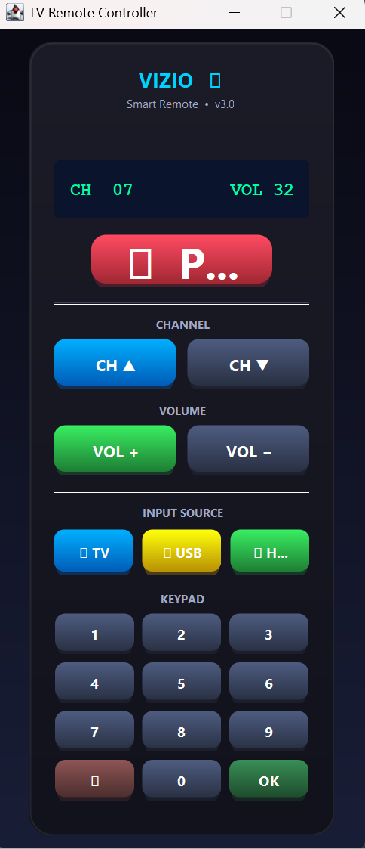

Task 3:
import javax.swing.*;
import javax.swing.border.*;
import java.awt.*;
import java.awt.event.*; // ActionListener lives here
/**
* Q3: Login Form with ActionListener
* ─────────────────────────────────────────────────────────────────────
* When the Login button is clicked → ActionListener fires →
* JOptionPane shows "Login Successful"
*
* UI: Dark purple/indigo theme, rounded card, glowing button
*/
public class Q3_LoginActionListener extends JFrame implements ActionListener {
// ─── Widgets ──────────────────────────────────────────────────────
private final JTextField usernameField;
private final JPasswordField passwordField;
private final JButton loginButton;
// ─── Palette ──────────────────────────────────────────────────────
private static final Color BG_TOP = new Color(18, 12, 45);
private static final Color BG_BOTTOM = new Color(45, 25, 90);
private static final Color CARD_BG = new Color(255, 255, 255, 22);
private static final Color ACCENT = new Color(149, 97, 255); // purple
private static final Color BTN_COLOR = new Color(109, 40, 217);
private static final Color WHITE = Color.WHITE;
private static final Color LABEL_CLR = new Color(200, 180, 255);
public Q3_LoginActionListener() {
setTitle("Secure Login — ActionListener Demo");
setSize(460, 520);
setDefaultCloseOperation(EXIT_ON_CLOSE);
setLocationRelativeTo(null);
setResizable(false);
// ── Background ────────────────────────────────────────────────
JPanel bg = new GradientPanel(BG_TOP, BG_BOTTOM);
bg.setLayout(new GridBagLayout());
setContentPane(bg);
// ── Card ──────────────────────────────────────────────────────
JPanel card = new RoundedPanel(28, CARD_BG);
card.setPreferredSize(new Dimension(360, 390));
card.setLayout(new GridBagLayout());
card.setBorder(BorderFactory.createEmptyBorder(30, 35, 30, 35));
GridBagConstraints g = new GridBagConstraints();
g.gridwidth = GridBagConstraints.REMAINDER;
g.fill = GridBagConstraints.HORIZONTAL;
// Title
JLabel title = new JLabel("🔑 Secure Login", SwingConstants.CENTER);
title.setFont(new Font("Segoe UI", Font.BOLD, 24));
title.setForeground(WHITE);
g.insets = new Insets(0, 0, 6, 0);
card.add(title, g);
// Tagline
JLabel tag = new JLabel("ActionListener powered authentication", SwingConstants.CENTER);
tag.setFont(new Font("Segoe UI", Font.ITALIC, 12));
tag.setForeground(new Color(180, 150, 255));
g.insets = new Insets(0, 0, 22, 0);
card.add(tag, g);
// Username label + field
card.add(fieldLabel(" 👤 Username"), withInset(g, 5, 0, 4, 0));
usernameField = styledField("Type your username…");
card.add(usernameField, withInset(g, 0, 0, 14, 0));
// Password label + field
card.add(fieldLabel(" 🔒 Password"), withInset(g, 5, 0, 4, 0));
passwordField = new JPasswordField();
stylePass(passwordField);
card.add(passwordField, withInset(g, 0, 0, 26, 0));
// Login button ← this is where ActionListener is registered
loginButton = new GlowButton(" LOGIN →", BTN_COLOR, 15);
loginButton.setPreferredSize(new Dimension(290, 46));
loginButton.addActionListener(this); // ← Q3 requirement
card.add(loginButton, withInset(g, 0, 0, 14, 0));
// Hint
JLabel hint = new JLabel("Click Login to fire the ActionListener", SwingConstants.CENTER);
hint.setFont(new Font("Segoe UI", Font.PLAIN, 11));
hint.setForeground(new Color(140, 110, 220));
g.insets = new Insets(4, 0, 0, 0);
card.add(hint, g);
bg.add(card);
setVisible(true);
}
// ════════════════════════════════════════════════════════════════
// ACTION LISTENER (Q3 requirement)
// ════════════════════════════════════════════════════════════════
@Override
public void actionPerformed(ActionEvent e) {
// This method runs when loginButton is clicked
if (e.getSource() == loginButton) {
// Show "Login Successful" via JOptionPane (exactly as Q3 asks)
JOptionPane.showMessageDialog(
this,
"✅ Login Successful!\n\nWelcome, " + usernameField.getText(),
"Authentication Result",
JOptionPane.INFORMATION_MESSAGE
);
}
}
// ════════════════════════════════════════════════════════════════
// Helpers
// ════════════════════════════════════════════════════════════════
private JLabel fieldLabel(String text) {
JLabel lbl = new JLabel(text);
lbl.setFont(new Font("Segoe UI", Font.BOLD, 13));
lbl.setForeground(LABEL_CLR);
return lbl;
}
private JTextField styledField(String ph) {
JTextField tf = new JTextField(ph);
tf.setPreferredSize(new Dimension(290, 42));
tf.setFont(new Font("Segoe UI", Font.PLAIN, 13));
tf.setForeground(new Color(200, 185, 255));
tf.setCaretColor(WHITE);
tf.setOpaque(false);
tf.setBorder(BorderFactory.createCompoundBorder(
new RoundedBorder(10, ACCENT),
BorderFactory.createEmptyBorder(5, 12, 5, 12)
));
return tf;
}
private void stylePass(JPasswordField f) {
f.setPreferredSize(new Dimension(290, 42));
f.setFont(new Font("Segoe UI", Font.PLAIN, 13));
f.setForeground(new Color(200, 185, 255));
f.setCaretColor(WHITE);
f.setOpaque(false);
f.setBorder(BorderFactory.createCompoundBorder(
new RoundedBorder(10, ACCENT),
BorderFactory.createEmptyBorder(5, 12, 5, 12)
));
}
private GridBagConstraints withInset(GridBagConstraints base, int t, int l, int b, int r) {
base.insets = new Insets(t, l, b, r);
return base;
}
// ════════════════════════════════════════════════════════════════
// Custom UI Components (reused across all question files)
// ════════════════════════════════════════════════════════════════
static class GradientPanel extends JPanel {
private final Color top, bot;
GradientPanel(Color top, Color bot) { this.top=top; this.bot=bot; }
@Override protected void paintComponent(Graphics g) {
Graphics2D g2 = (Graphics2D)g;
g2.setPaint(new GradientPaint(0,0,top,0,getHeight(),bot));
g2.fillRect(0,0,getWidth(),getHeight());
}
}
static class RoundedPanel extends JPanel {
private final int arc; private final Color fill;
RoundedPanel(int arc, Color fill) { this.arc=arc; this.fill=fill; setOpaque(false); }
@Override protected void paintComponent(Graphics g) {
Graphics2D g2=(Graphics2D)g.create();
g2.setRenderingHint(RenderingHints.KEY_ANTIALIASING,RenderingHints.VALUE_ANTIALIAS_ON);
g2.setColor(fill); g2.fillRoundRect(0,0,getWidth(),getHeight(),arc,arc);
g2.setColor(new Color(255,255,255,50)); g2.setStroke(new BasicStroke(1.2f));
g2.drawRoundRect(1,1,getWidth()-2,getHeight()-2,arc,arc);
g2.dispose(); super.paintComponent(g);
}
}
static class RoundedBorder extends AbstractBorder {
private final int r; private final Color c;
RoundedBorder(int r,Color c){this.r=r;this.c=c;}
@Override public void paintBorder(Component comp,Graphics g,int x,int y,int w,int h){
Graphics2D g2=(Graphics2D)g.create();
g2.setRenderingHint(RenderingHints.KEY_ANTIALIASING,RenderingHints.VALUE_ANTIALIAS_ON);
g2.setColor(c); g2.setStroke(new BasicStroke(1.5f));
g2.drawRoundRect(x,y,w-1,h-1,r,r); g2.dispose();
}
}
static class GlowButton extends JButton {
private final Color base;
GlowButton(String txt, Color base, int fs) {
super(txt); this.base=base;
setFont(new Font("Segoe UI",Font.BOLD,fs));
setForeground(Color.WHITE);
setFocusPainted(false); setBorderPainted(false); setContentAreaFilled(false);
setCursor(Cursor.getPredefinedCursor(Cursor.HAND_CURSOR));
}
@Override protected void paintComponent(Graphics g) {
Graphics2D g2=(Graphics2D)g.create();
g2.setRenderingHint(RenderingHints.KEY_ANTIALIASING,RenderingHints.VALUE_ANTIALIAS_ON);
g2.setColor(new Color(base.getRed(),base.getGreen(),base.getBlue(),55));
g2.fillRoundRect(3,5,getWidth()-6,getHeight()-2,24,24);
g2.setPaint(new GradientPaint(0,0,base.brighter(),0,getHeight(),base.darker()));
g2.fillRoundRect(0,0,getWidth(),getHeight()-3,24,24);
g2.dispose(); super.paintComponent(g);
}
}
public static void main(String[] args) {
try { UIManager.setLookAndFeel(UIManager.getCrossPlatformLookAndFeelClassName()); }
catch (Exception ignored) {}
SwingUtilities.invokeLater(Q3_LoginActionListener::new);
}
}
Output:
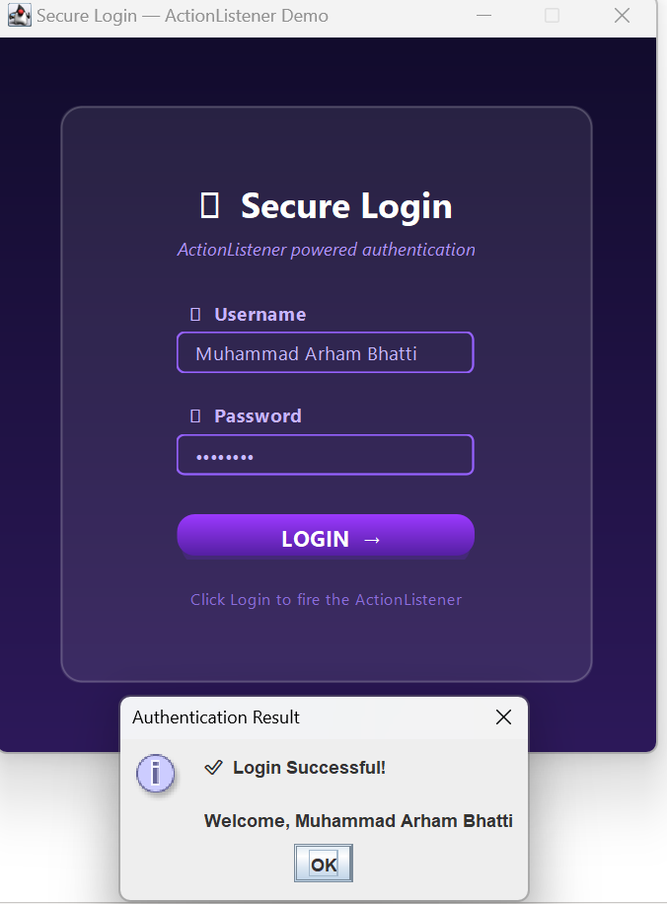

Task 4:
import javax.swing.*;
import javax.swing.border.*;
import java.awt.*;
import java.awt.event.*; // MouseListener lives here
/**
* Q4: Addition Calculator with MouseListener
* ─────────────────────────────────────────────────────────────────────
* Takes two numbers → adds them → shows result on screen (not dialog)
* Uses MouseListener on the "Calculate" button (mouseClicked method)
*
* UI: Teal / dark-green cyber theme with animated result label
*/
public class Q4_AdditionMouseListener extends JFrame implements MouseListener {
// ─── Widgets ──────────────────────────────────────────────────────
private final JTextField num1Field;
private final JTextField num2Field;
private final JLabel resultLabel; // result shown on screen
private final JLabel resultValue; // the actual number
private final JButton calcButton;
private final JLabel errorLabel;
// ─── Palette ──────────────────────────────────────────────────────
private static final Color BG_TOP = new Color(5, 25, 35);
private static final Color BG_BOTTOM = new Color(10, 50, 60);
private static final Color CARD_BG = new Color(255,255,255, 20);
private static final Color ACCENT = new Color(0, 210, 180); // teal
private static final Color BTN_BASE = new Color(0, 160, 130);
private static final Color RESULT_BG = new Color(0, 35, 30);
private static final Color RESULT_FG = new Color(0, 255, 200); // matrix teal
private static final Color WHITE = Color.WHITE;
private static final Color LABEL_CLR = new Color(150, 230, 220);
public Q4_AdditionMouseListener() {
setTitle("Addition Calculator — MouseListener Demo");
setSize(460, 540);
setDefaultCloseOperation(EXIT_ON_CLOSE);
setLocationRelativeTo(null);
setResizable(false);
// ── Background ────────────────────────────────────────────────
JPanel bg = new GradientPanel(BG_TOP, BG_BOTTOM);
bg.setLayout(new GridBagLayout());
setContentPane(bg);
// ── Card ──────────────────────────────────────────────────────
JPanel card = new RoundedPanel(28, CARD_BG);
card.setPreferredSize(new Dimension(370, 450));
card.setLayout(new GridBagLayout());
card.setBorder(BorderFactory.createEmptyBorder(28, 35, 28, 35));
GridBagConstraints g = new GridBagConstraints();
g.gridwidth = GridBagConstraints.REMAINDER;
g.fill = GridBagConstraints.HORIZONTAL;
// Title
JLabel title = new JLabel("➕ Addition Calculator", SwingConstants.CENTER);
title.setFont(new Font("Segoe UI", Font.BOLD, 22));
title.setForeground(WHITE);
g.insets = new Insets(0, 0, 5, 0);
card.add(title, g);
JLabel sub = new JLabel("MouseListener detects the click", SwingConstants.CENTER);
sub.setFont(new Font("Segoe UI", Font.ITALIC, 12));
sub.setForeground(new Color(100, 200, 190));
g.insets = new Insets(0, 0, 20, 0);
card.add(sub, g);
// Number 1
card.add(fieldLabel(" First Number"), withInset(g, 4, 0, 4, 0));
num1Field = styledField("Enter first number…");
card.add(num1Field, withInset(g, 0, 0, 12, 0));
// Plus symbol
JLabel plus = new JLabel("+", SwingConstants.CENTER);
plus.setFont(new Font("Segoe UI", Font.BOLD, 28));
plus.setForeground(ACCENT);
g.insets = new Insets(0, 0, 12, 0);
card.add(plus, g);
// Number 2
card.add(fieldLabel(" Second Number"), withInset(g, 0, 0, 4, 0));
num2Field = styledField("Enter second number…");
card.add(num2Field, withInset(g, 0, 0, 18, 0));
// Calculate button – MouseListener registered here
calcButton = new GlowButton(" CALCULATE +", BTN_BASE, 15);
calcButton.setPreferredSize(new Dimension(300, 46));
calcButton.addMouseListener(this); // ← Q4 requirement
g.insets = new Insets(0, 0, 14, 0);
card.add(calcButton, g);
// Error label (hidden until needed)
errorLabel = new JLabel("", SwingConstants.CENTER);
errorLabel.setFont(new Font("Segoe UI", Font.PLAIN, 12));
errorLabel.setForeground(new Color(255, 100, 100));
g.insets = new Insets(0, 0, 8, 0);
card.add(errorLabel, g);
// Result box (on-screen display – Q4 requirement)
JPanel resultBox = new RoundedPanel(16, RESULT_BG);
resultBox.setPreferredSize(new Dimension(300, 70));
resultBox.setLayout(new GridBagLayout());
resultBox.setBorder(BorderFactory.createCompoundBorder(
new RoundedBorder(16, ACCENT),
BorderFactory.createEmptyBorder(5, 10, 5, 10)
));
GridBagConstraints rg = new GridBagConstraints();
rg.gridwidth = GridBagConstraints.REMAINDER;
resultLabel = new JLabel("Result", SwingConstants.CENTER);
resultLabel.setFont(new Font("Segoe UI", Font.PLAIN, 12));
resultLabel.setForeground(new Color(100, 200, 190));
resultBox.add(resultLabel, rg);
resultValue = new JLabel("—", SwingConstants.CENTER);
resultValue.setFont(new Font("Courier New", Font.BOLD, 30));
resultValue.setForeground(RESULT_FG);
resultBox.add(resultValue, rg);
g.insets = new Insets(0, 0, 0, 0);
card.add(resultBox, g);
bg.add(card);
setVisible(true);
}
// ════════════════════════════════════════════════════════════════
// MOUSE LISTENER (Q4 requirement — perform addition on click)
// ════════════════════════════════════════════════════════════════
@Override
public void mouseClicked(MouseEvent e) {
// This fires when the mouse is pressed AND released on the button
if (e.getSource() == calcButton) {
performAddition();
}
}
// The other four methods are required by the interface but we leave them empty
@Override public void mousePressed (MouseEvent e) { /* not used */ }
@Override public void mouseReleased(MouseEvent e) { /* not used */ }
@Override public void mouseEntered (MouseEvent e) {
// Subtle hover glow effect
calcButton.setBackground(BTN_BASE.brighter());
}
@Override public void mouseExited (MouseEvent e) {
calcButton.setBackground(BTN_BASE);
}
// ── Core logic ──
private void performAddition() {
errorLabel.setText("");
try {
double a = Double.parseDouble(num1Field.getText().trim());
double b = Double.parseDouble(num2Field.getText().trim());
double sum = a + b;
// Show result on screen (label, not dialog)
resultLabel.setText(num1Field.getText().trim() + " + " + num2Field.getText().trim() + " =");
// Format: if whole number, show without .0
if (sum == Math.floor(sum) && !Double.isInfinite(sum))
resultValue.setText(String.valueOf((long) sum));
else
resultValue.setText(String.valueOf(sum));
} catch (NumberFormatException ex) {
errorLabel.setText("⚠ Please enter valid numbers in both fields.");
resultValue.setText("—");
resultLabel.setText("Result");
}
}
// ════════════════════════════════════════════════════════════════
// Helpers
// ════════════════════════════════════════════════════════════════
private JLabel fieldLabel(String text) {
JLabel lbl = new JLabel(text);
lbl.setFont(new Font("Segoe UI", Font.BOLD, 13));
lbl.setForeground(LABEL_CLR);
return lbl;
}
private JTextField styledField(String ph) {
JTextField tf = new JTextField(ph);
tf.setPreferredSize(new Dimension(300, 42));
tf.setFont(new Font("Segoe UI", Font.PLAIN, 13));
tf.setForeground(ACCENT);
tf.setCaretColor(WHITE);
tf.setOpaque(false);
tf.setBorder(BorderFactory.createCompoundBorder(
new RoundedBorder(10, ACCENT),
BorderFactory.createEmptyBorder(5, 12, 5, 12)
));
return tf;
}
private GridBagConstraints withInset(GridBagConstraints b, int t, int l, int bot, int r) {
b.insets = new Insets(t, l, bot, r); return b;
}
// ── Shared custom components (same design system) ──
static class GradientPanel extends JPanel {
private final Color top, bot;
GradientPanel(Color top, Color bot) { this.top=top; this.bot=bot; }
@Override protected void paintComponent(Graphics g) {
Graphics2D g2=(Graphics2D)g;
g2.setPaint(new GradientPaint(0,0,top,0,getHeight(),bot));
g2.fillRect(0,0,getWidth(),getHeight());
}
}
static class RoundedPanel extends JPanel {
private final int arc; private final Color fill;
RoundedPanel(int arc, Color fill) { this.arc=arc; this.fill=fill; setOpaque(false); }
@Override protected void paintComponent(Graphics g) {
Graphics2D g2=(Graphics2D)g.create();
g2.setRenderingHint(RenderingHints.KEY_ANTIALIASING,RenderingHints.VALUE_ANTIALIAS_ON);
g2.setColor(fill); g2.fillRoundRect(0,0,getWidth(),getHeight(),arc,arc);
g2.setColor(new Color(255,255,255,40)); g2.setStroke(new BasicStroke(1.2f));
g2.drawRoundRect(1,1,getWidth()-2,getHeight()-2,arc,arc);
g2.dispose(); super.paintComponent(g);
}
}
static class RoundedBorder extends AbstractBorder {
private final int r; private final Color c;
RoundedBorder(int r, Color c) { this.r=r; this.c=c; }
@Override public void paintBorder(Component comp, Graphics g, int x, int y, int w, int h) {
Graphics2D g2=(Graphics2D)g.create();
g2.setRenderingHint(RenderingHints.KEY_ANTIALIASING,RenderingHints.VALUE_ANTIALIAS_ON);
g2.setColor(c); g2.setStroke(new BasicStroke(1.5f));
g2.drawRoundRect(x,y,w-1,h-1,r,r); g2.dispose();
}
}
static class GlowButton extends JButton {
private final Color base;
GlowButton(String txt, Color base, int fs) {
super(txt); this.base=base;
setFont(new Font("Segoe UI",Font.BOLD,fs));
setForeground(Color.WHITE);
setFocusPainted(false); setBorderPainted(false); setContentAreaFilled(false);
setCursor(Cursor.getPredefinedCursor(Cursor.HAND_CURSOR));
}
@Override protected void paintComponent(Graphics g) {
Graphics2D g2=(Graphics2D)g.create();
g2.setRenderingHint(RenderingHints.KEY_ANTIALIASING,RenderingHints.VALUE_ANTIALIAS_ON);
g2.setColor(new Color(base.getRed(),base.getGreen(),base.getBlue(),55));
g2.fillRoundRect(3,5,getWidth()-6,getHeight()-2,24,24);
g2.setPaint(new GradientPaint(0,0,base.brighter(),0,getHeight(),base.darker()));
g2.fillRoundRect(0,0,getWidth(),getHeight()-3,24,24);
g2.dispose(); super.paintComponent(g);
}
}
public static void main(String[] args) {
try { UIManager.setLookAndFeel(UIManager.getCrossPlatformLookAndFeelClassName()); }
catch (Exception ignored) {}
SwingUtilities.invokeLater(Q4_AdditionMouseListener::new);
}
}
Output:
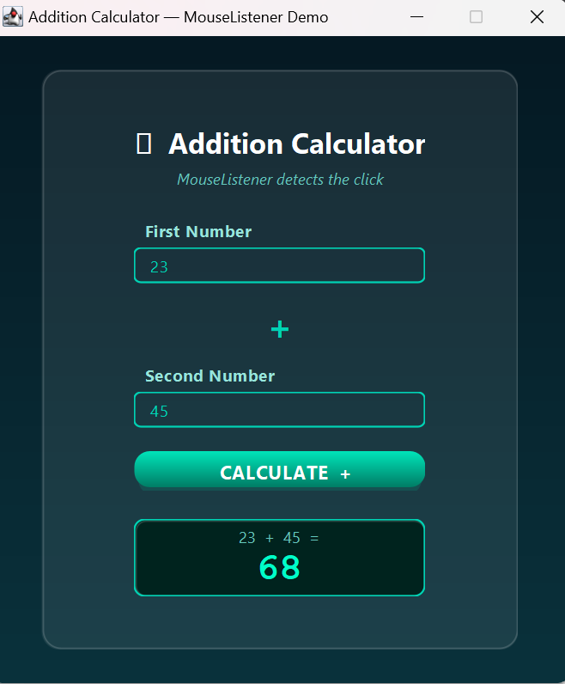
Task 5:
import javax.swing.*;
import javax.swing.border.*;
import java.awt.*;
import java.awt.event.*; // KeyListener lives here
/**
* Q5: Number Checker with KeyListener
* ─────────────────────────────────────────────────────────────────────
* User types a number → KeyListener detects keyboard input →
* JLabel on screen shows: "Positive Number" / "Negative Number" / "Zero"
*
* UI: Warm amber / dark-orange theme, live response as you type
*/
public class Q5_NumberCheckerKeyListener extends JFrame implements KeyListener {
// ─── Widgets ──────────────────────────────────────────────────────
private final JTextField inputField;
private final JLabel statusLabel; // shows Positive / Negative / Zero
private final JLabel iconLabel; // emoji icon
private final JLabel descLabel; // brief description
// ─── Palette ──────────────────────────────────────────────────────
private static final Color BG_TOP = new Color(30, 15, 5);
private static final Color BG_BOTTOM = new Color(60, 30, 5);
private static final Color CARD_BG = new Color(255, 255, 255, 20);
private static final Color ACCENT = new Color(251, 146, 60); // amber
private static final Color BOX_BG = new Color(40, 20, 5);
private static final Color POS_COLOR = new Color(74, 222, 128); // green
private static final Color NEG_COLOR = new Color(248, 113, 113); // red
private static final Color ZERO_COLOR = new Color(147, 197, 253); // blue
private static final Color IDLE_COLOR = new Color(160, 140, 120);
private static final Color WHITE = Color.WHITE;
public Q5_NumberCheckerKeyListener() {
setTitle("Number Checker — KeyListener Demo");
setSize(440, 500);
setDefaultCloseOperation(EXIT_ON_CLOSE);
setLocationRelativeTo(null);
setResizable(false);
// ── Background ────────────────────────────────────────────────
JPanel bg = new GradientPanel(BG_TOP, BG_BOTTOM);
bg.setLayout(new GridBagLayout());
setContentPane(bg);
// ── Card ──────────────────────────────────────────────────────
JPanel card = new RoundedPanel(28, CARD_BG);
card.setPreferredSize(new Dimension(360, 400));
card.setLayout(new GridBagLayout());
card.setBorder(BorderFactory.createEmptyBorder(30, 35, 30, 35));
GridBagConstraints g = new GridBagConstraints();
g.gridwidth = GridBagConstraints.REMAINDER;
g.fill = GridBagConstraints.HORIZONTAL;
// Title
JLabel title = new JLabel("🔢 Number Checker", SwingConstants.CENTER);
title.setFont(new Font("Segoe UI", Font.BOLD, 23));
title.setForeground(WHITE);
g.insets = new Insets(0, 0, 5, 0);
card.add(title, g);
JLabel sub = new JLabel("KeyListener updates result as you type", SwingConstants.CENTER);
sub.setFont(new Font("Segoe UI", Font.ITALIC, 12));
sub.setForeground(ACCENT);
g.insets = new Insets(0, 0, 22, 0);
card.add(sub, g);
// Instruction label
JLabel lbl = new JLabel(" Enter any number:");
lbl.setFont(new Font("Segoe UI", Font.BOLD, 13));
lbl.setForeground(new Color(255, 200, 140));
g.insets = new Insets(0, 0, 5, 0);
card.add(lbl, g);
// Input field – KeyListener registered here
inputField = new JTextField();
inputField.setPreferredSize(new Dimension(290, 48));
inputField.setFont(new Font("Courier New", Font.BOLD, 20));
inputField.setForeground(ACCENT);
inputField.setCaretColor(WHITE);
inputField.setOpaque(false);
inputField.setBorder(BorderFactory.createCompoundBorder(
new RoundedBorder(12, ACCENT),
BorderFactory.createEmptyBorder(5, 14, 5, 14)
));
inputField.setHorizontalAlignment(SwingConstants.CENTER);
inputField.addKeyListener(this); // ← Q5 requirement
g.insets = new Insets(0, 0, 24, 0);
card.add(inputField, g);
// ── Result display box ────────────────────────────────────────
JPanel resultBox = new RoundedPanel(18, new Color(0, 0, 0, 50));
resultBox.setPreferredSize(new Dimension(290, 140));
resultBox.setLayout(new GridBagLayout());
resultBox.setBorder(BorderFactory.createCompoundBorder(
new RoundedBorder(18, new Color(255, 255, 255, 35)),
BorderFactory.createEmptyBorder(10, 10, 10, 10)
));
GridBagConstraints rg = new GridBagConstraints();
rg.gridwidth = GridBagConstraints.REMAINDER;
iconLabel = new JLabel("❓", SwingConstants.CENTER);
iconLabel.setFont(new Font("Segoe UI", Font.PLAIN, 40));
rg.insets = new Insets(0, 0, 5, 0);
resultBox.add(iconLabel, rg);
statusLabel = new JLabel("Waiting for input…", SwingConstants.CENTER);
statusLabel.setFont(new Font("Segoe UI", Font.BOLD, 20));
statusLabel.setForeground(IDLE_COLOR);
rg.insets = new Insets(0, 0, 4, 0);
resultBox.add(statusLabel, rg);
descLabel = new JLabel("Start typing above", SwingConstants.CENTER);
descLabel.setFont(new Font("Segoe UI", Font.PLAIN, 12));
descLabel.setForeground(new Color(140, 130, 115));
rg.insets = new Insets(0, 0, 0, 0);
resultBox.add(descLabel, rg);
g.insets = new Insets(0, 0, 0, 0);
card.add(resultBox, g);
bg.add(card);
setVisible(true);
inputField.requestFocusInWindow();
}
// ════════════════════════════════════════════════════════════════
// KEY LISTENER (Q5 requirement — check number on key press)
// ════════════════════════════════════════════════════════════════
@Override
public void keyReleased(KeyEvent e) {
// keyReleased fires AFTER the character is committed to the text field,
// so inputField.getText() already contains the latest full value.
checkNumber();
}
// keyTyped and keyPressed are required by the interface; we leave them empty
// because we only need to react after the field text is fully updated.
@Override public void keyTyped (KeyEvent e) { /* not used */ }
@Override public void keyPressed(KeyEvent e) { /* not used */ }
// ── Core logic ──
private void checkNumber() {
String text = inputField.getText().trim();
if (text.isEmpty() || text.equals("-") || text.equals(".")) {
// Field is empty or has only a minus sign – reset display
statusLabel.setText("Waiting for input…");
statusLabel.setForeground(IDLE_COLOR);
iconLabel.setText("❓");
descLabel.setText("Start typing above");
return;
}
try {
double number = Double.parseDouble(text);
if (number > 0) {
// ── Positive ──
statusLabel.setText("Positive Number");
statusLabel.setForeground(POS_COLOR);
iconLabel.setText("⬆");
descLabel.setText(text + " is greater than zero");
} else if (number < 0) {
// ── Negative ──
statusLabel.setText("Negative Number");
statusLabel.setForeground(NEG_COLOR);
iconLabel.setText("⬇");
descLabel.setText(text + " is less than zero");
} else {
// ── Zero ──
statusLabel.setText("Zero");
statusLabel.setForeground(ZERO_COLOR);
iconLabel.setText("⚬");
descLabel.setText("The number is exactly 0");
}
} catch (NumberFormatException ex) {
// User typed something non-numeric
statusLabel.setText("Invalid Input");
statusLabel.setForeground(new Color(255, 120, 50));
iconLabel.setText("⚠");
descLabel.setText("Please enter a valid number");
}
}
// ════════════════════════════════════════════════════════════════
// Shared custom components (same design system as other files)
// ════════════════════════════════════════════════════════════════
static class GradientPanel extends JPanel {
private final Color top, bot;
GradientPanel(Color top, Color bot) { this.top=top; this.bot=bot; }
@Override protected void paintComponent(Graphics g) {
Graphics2D g2=(Graphics2D)g;
g2.setPaint(new GradientPaint(0,0,top,0,getHeight(),bot));
g2.fillRect(0,0,getWidth(),getHeight());
}
}
static class RoundedPanel extends JPanel {
private final int arc; private final Color fill;
RoundedPanel(int arc, Color fill) { this.arc=arc; this.fill=fill; setOpaque(false); }
@Override protected void paintComponent(Graphics g) {
Graphics2D g2=(Graphics2D)g.create();
g2.setRenderingHint(RenderingHints.KEY_ANTIALIASING,RenderingHints.VALUE_ANTIALIAS_ON);
g2.setColor(fill); g2.fillRoundRect(0,0,getWidth(),getHeight(),arc,arc);
g2.setColor(new Color(255,255,255,40)); g2.setStroke(new BasicStroke(1.2f));
g2.drawRoundRect(1,1,getWidth()-2,getHeight()-2,arc,arc);
g2.dispose(); super.paintComponent(g);
}
}
static class RoundedBorder extends AbstractBorder {
private final int r; private final Color c;
RoundedBorder(int r, Color c) { this.r=r; this.c=c; }
@Override public void paintBorder(Component comp, Graphics g, int x, int y, int w, int h) {
Graphics2D g2=(Graphics2D)g.create();
g2.setRenderingHint(RenderingHints.KEY_ANTIALIASING,RenderingHints.VALUE_ANTIALIAS_ON);
g2.setColor(c); g2.setStroke(new BasicStroke(1.5f));
g2.drawRoundRect(x,y,w-1,h-1,r,r); g2.dispose();
}
}
public static void main(String[] args) {
try { UIManager.setLookAndFeel(UIManager.getCrossPlatformLookAndFeelClassName()); }
catch (Exception ignored) {}
SwingUtilities.invokeLater(Q5_NumberCheckerKeyListener::new);
}
}

Output:
